Cascading Style Sheets (CSS)

Responsible for describing the presentation of a HTML file

1. CSS allows to change the style attribute of HTML elements like the
2. Background
3. Color
4. Borders
5. Steps
6. Create a .CSS file
7. Use CSS syntax to link elements tags
8. Place the .CSS and HTML file in the same location.
9. link .CSS file to HTML (through a call in the header of the HTML file)
10. Link the html and CSS files; and add element wise coloring

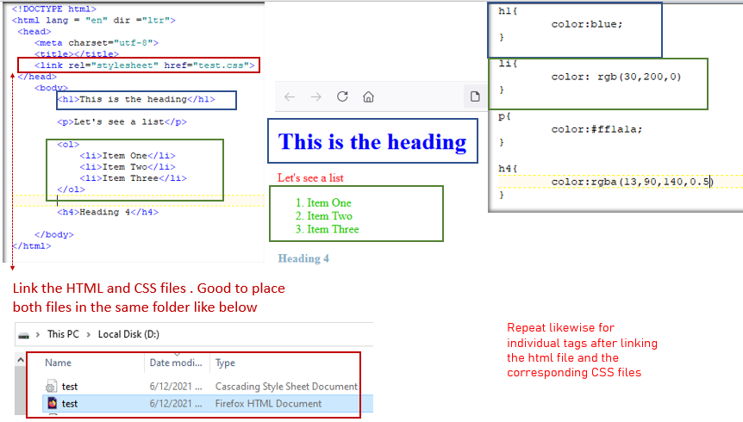

1. Add a background image
2. copy the link of an image from a website (in my case, I go to unplash.com)
3. paste as below; along with additional arguments

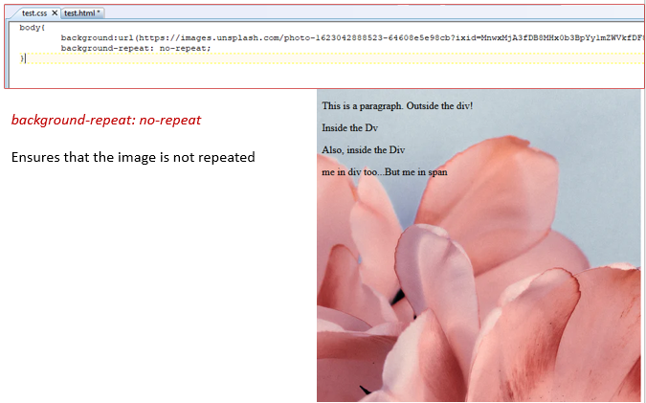

1. Different treatment for a Div. and Span within the Div.

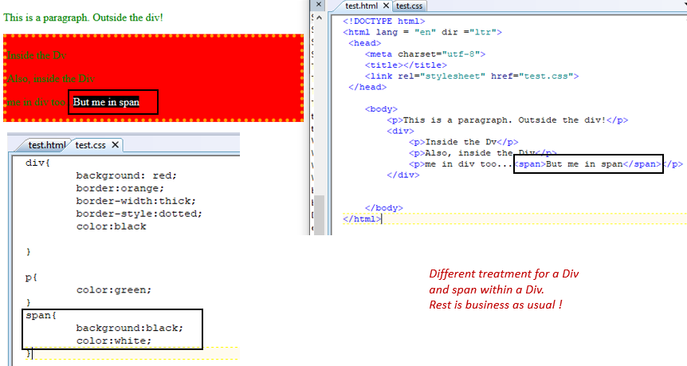

1. Differentiate similar tags through the use of classes and ids in the CSS.

There could be multiple paragraphs and Div within a HTML file. Specifying just the “p” could apply the coloring etc. across all paragraphs. In order to treat different paragraphs differently; we use classes and ids for unique identification and mapping between the CSS and HTML files.

The difference between class and ids being; class is used to differentiate between Div tags whereas id is used to differentiate between individual html element tags.

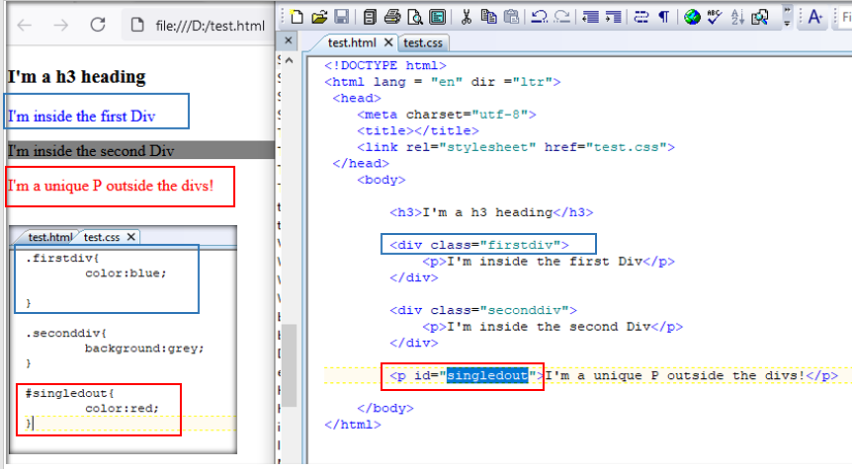

1. Changing HTML fonts through CSS

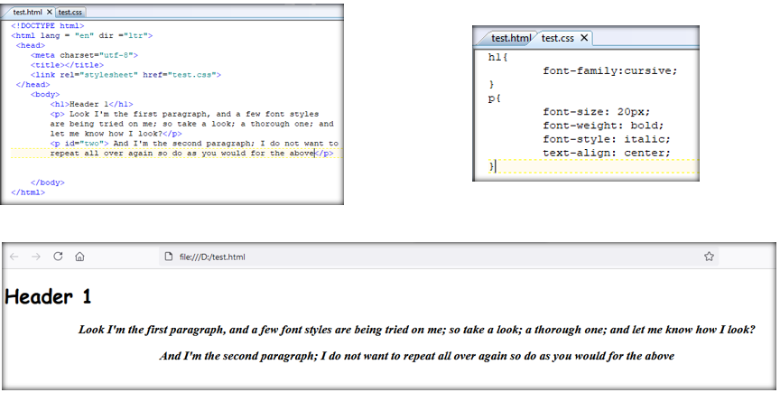

1. Importing fonts from online sources

Not all machines have all types of fonts; and the collection of font varies with the operating system i.e mac, windows etc.

There are ways of importing font styles available online

1. To import from Google Fonts
2. Go to fonts.google.com
3. Browse through and select the desired font
4. Find the link and font-family type associated with the font (click on the ‘+’ button on the right)
5. Copy and add the link to html header and font family to CSS respectively.

